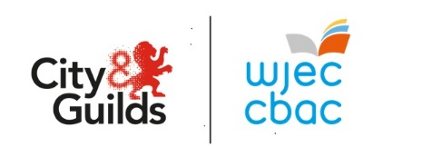

Pwyntiau UCAS ar gyfer
CBAC Lefel 3 Gofal, Chwarae, Dysgu, a Datblygiad Plant: Ymarfer a Theori (Ardystiad Cyntaf 2025)

A*- 168
A - 144
B - 120
C - 96
D - 72
E - 48

https://www.ucas.com/ucas/tariff-calculator

